Title of the extended abstract (capitals for first word and proper nouns only)
Blank line 12 pt
Blank line 12 pt
First Author ¹, Second Author ^{2,3}, Third Author ³
Blank Line 9 pt
¹Institutional Affiliation, City, Country, Email address
²Institutional Affiliation, City, Country, Email address
³Institutional Affiliation, City, Country, Email address
Blank line 12 pt
Blank line 12 pt
SUMMARY: (10 pt)
Type your summary of maximum 200 words. The summary can be the same as the one used in the on-line submission form. The summary title has to be 9 cm from the top. For summary title use Times New Roman 10 point bold, while for summary text Times New Roman 10 pt regular and left alignment, single line spacing.
Blank line 10 pt
Keywords: keyword 1, keyword 2, keyword 3 (one line of text but not more than 3 free keywords, Times New Roman 10 pt italic, keywords must be separated by commas)
Blank line 12 pt
Blank line 12 pt
1. GENERAL INSTRUCTIONS
The text should fit exactly into the type area. A4 paper size margins are set to: Top: 2.54 cm; Bottom: 2.54 cm; Left: 2.54 cm; Right: 2.54 cm. Use Times New Roman 12pt size and single line spacing. Never use bold, except for the headings and never underline any text. Use the smaller font (10pt) for tables, figure captions and the acknowledgement and references. Do not use/insert page numbers.
Blank line 12 pt
The extended abstract must be no longer than 4 pages, including summary, text, figures, tables and references.
Blank line 12 pt
The extended abstract should give an overview of the work, including motivations, methods, results, conclusions, possible acknowledgments, and essential references. Preparation of figures and tables must follow the indications provided on the next pages.
Blank line 12 pt
1.1. Title, author and affiliation
Title of the contribution, use Times New Roman 18pt bold, centre alignment and single line spacing. The title must not be more than three lines of text.
Blank line 12 pt
To list authors, use Times New Roman 12pt (initials then surname) underline the presenting author, affiliation reference number should be superscript, if the author is linked to more than one institute include all the reference numbers.
Blank line 12 pt
Leave one blank line before listing all author affiliations, use Times New Roman 12pt. Affiliation reference number should be superscript, affiliations should be separated by a comma.
Blank line 12 pt
Blank line 12 pt
2. SECTION HEADING (12pt BOLD AND ALL CAPS)
Section headings are to be in Times New Roman 12pt bold and full caps. Number the headings consecutively. Leave two blank lines before Section Heading.
Blank line 12 pt
Between paragraphs of text leave one blank line gap. Paragraphs are not to have any indents. Text should be single spaced, alignment-justified.
Blank line 12 pt
2.1. Secondary Heading or Sub-headings (12 pt bold, only first letter capital)
Sub-headings are printed in Times New Roman 12pt bold. Use upper and lower case letters. Leave one blank line above a sub-heading and the last line of text.
Blank line 12 pt
2.1.1. Tertiary headings
Tertiary headings are printed in Times New Roman 12pt italics, and numbered. Leave one blank line above a tertiary heading and the last line of text.
Blank line 12 pt
Blank line 12 pt
3. TABLES
Authors may choose how they wish to format the table layout. Use Times New Roman 10 pt for table heading and for table text. Table heading should be left alignment (e.g. the beginning of the table). Number the table headings and please be consistent throughout your manuscript. Leave one blank line before table heading and one blank line after the table, as in Table 1 shown below.
Blank line 12 pt
Table 1. (10pt bold) Margin settings for A4 size paper (10 pt regular).
Row 1 | A | B | C | D
Row 2 | 1 | 2 | 3 | 4
Row 3 | Text | text | Text | Text
Row 4 | 123 | 123 | 123 | 123
Blank line 12 pt
Text after the table.
Blank line 12 pt
Blank line 12 pt
4. ILLUSTRATIONS AND DIAGRAMS
Illustrations and diagrams are to be centred, with the reference and caption below the figure having one blank line 10 pt. Type as follows: ‘Figure 1. Caption’, Times New Roman 10 pt.
Blank line 12 pt
The lettering used in the illustrations should not be too small. Illustrations are to be referred to as figures, and must be quoted in the text, e.g. see Fig. 1, or in Fig. 1 it is shown… One blank line should be left between the text and figure, as well as the figure caption and the next paragraph. Keep figures as simple as possible. Resolution must be at least 250 dpi.

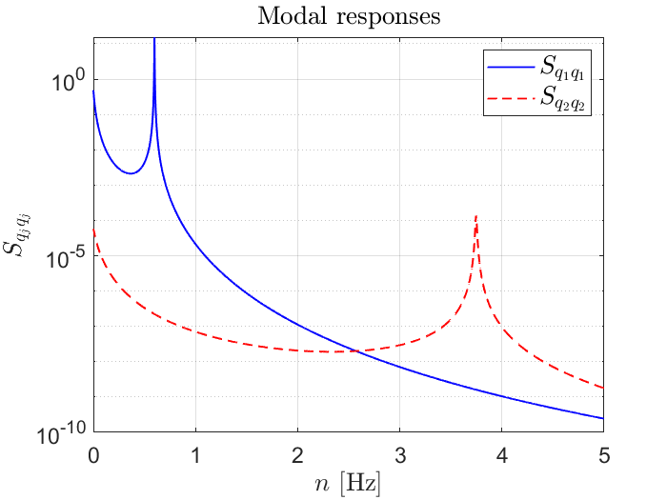
Blank line 10 pt
Figure 1. Example of figure.
Blank line 12 pt
5. EQUATIONS
Use the equation editor of the selected word processing programme. Equations are aligned with the left margin. Number equations consecutively and place the number with the tab key at the end of the line, between parentheses. Refer to equations by these numbers. Leave one blank line above and also below any equation. Equation references are in the form of “equation number” and should be referred to in the text in the form Eq. (1). Equations should be typed and all symbols should be explained within the text of your manuscript.
Blank line 12 pt
$K= \frac{mc^{2}}{\sqrt{1-{\left(v/c\right)}^{2}}}-mc^{2}$${\left(x+a\right)}^{n}=\sum_{k=0}^{n}{\left({n \atop k}\right)x^{k}a^{n-k}}$ (1)
Blank line 12 pt
Blank line 12 pt
6. REFERENCES
Citations to references in the text must follow the format shown here (Davenport, 1968; Jain, 1997; Scanlan et al., 1974; Simiu and Scanlan, 1996; Vickery and Basu, 1983). The references are listed in alphabetical order by first author (Melbourne, 1980) and formatted as shown by the examples at the end of this template. For more than two authors the citation should replace all authors except the first one with “et al”. The list of references must be placed at the end of the text in a separate section, after “ACKNOWLEDGEMENTS” and should be typed in 10 pt Times New Roman.
Blank line 12 pt
Blank line 12 pt
7. CONCLUSIONS: FINAL CHECKS AND SUBMISSION
Once the text is complete, we recommend that you run a spell check through the text. Convert the document to a PDF file and upload it, together with the source Word file, through the on-line abstract submission process. Please go to www.icwe2023.com and follow the instructions under “Abstract Submission”. If you have any questions, please contact the Organising Committee at: org.committee@icwe2023.unifi.it.
Blank line 12 pt
For submission, the name of the file that you choose is not important. Files will automatically be renamed by our on-line system after submission. Please submit your extended abstract by 15th December 2022. If the submitted extended abstract is not prepared according to above guidelines, it may not be accepted.
Blank line 12 pt
ACKNOWLEDGEMENTS
For acknowledgements and references use Times New Roman 10pt regular, the heading title should be bold and all caps, but not numbered. Leave two blank lines after the text 10pt size.
Blank line 10 pt
Blank line 10 pt
REFERENCES
Davenport, A. G., 1968. The dependence of wind loads on meteorological parameters. Proceedings of Proceedings International Research Seminar “Wind effects on buildings and structures", 11-15 Sept. 1967. Ottawa, Canada, 19–82.
Jain, A., 1997. Multi-mode aeroelastic and aerodynamic analysis of long-span bridges. Ph.D. Dissertation, Johns Hopkins University, Baltimore, Maryland, USA.
Melbourne, W. H., 1980. Comparison of measurements on the CAARC standard tall building model in simulated model wind flows. Journal of Wind Engineering and Industrial Aerodynamics 6, 73–88.
Scanlan, R. H., Béliveau, J.-G., and Budlong, K. S., 1974. Indicial aerodynamic functions for bridge decks. Journal of the Engineering Mechanics Division, ASCE 100, 73–88.
Simiu, E. and Scanlan, R. H., 1996. Wind effects on structures: fundamentals and applications to design. 3rd ed. John Wiley & Sons, New York, USA.
Vickery, B. J. and Basu, R., 1983. Simplified approaches to the evaluation of the across-wind response of chimneys. Journal of Wind Engineering and Industrial Aerodynamics 14, 153–166.

