Style template for ICWE 2023 conference
First A. Author^{1,*}, Second B. Author² and Third C. Author¹
¹ Department of Civil and Environmental Engineering, Università di Firenze,
Via Santa Marta 3, 50139, Firenze, (Italy)
first.author@unifi.it; third.author@unifi.it
² Department of Mechanical and Aerospace Engineering, Università di Roma “Sapienza”,
Via Eudossiana18, 00184, Roma, (Italy)
second.author@uniroma1.it
Abstract These instructions give you guidelines for preparing the full paper for ICWE 2023, the XVI International Conference on Wind Engineering in MS Word format. For submission guidelines, follow instructions on the Conference website. The abstract must be composed by a single paragraph of maximum 200 words, justified between the margins specified below. The font is Times size 9. The paragraph has 12pt minimum line space with 24pt blank space above.

Keywords: lattice tower · CFD model · up to 6 keywords
1 Introduction
This document is a guide for MS Word users. If you are reading the PDF version of it, please download the file, ICWE_2023_Full_Paper_WordTemplate.docx. A paper length of either 10 or 12 is recommended (in any case, no more than 12 pages are allowed: those papers exceeding this limit will not be reviewed).
2 Page Size, Margins and Font
The page size is standard A4, with the margins listed in Table 1. The text area is 16.0 cm × 24.7 cm. The document is based on the font Times. The standard font size is 10pt. The paper title is 16pt bold faced. Section titles are 12pt bold faced; subsection titles are 10pt italics. Figure and table captions are 8.5pt.
Table 1 Margins for paper submitted to ICWE 2023 conference
Page | Top | Bottom | Left | Right
First | 5.0 | 5.6 | 4.7 | 4.25
Rest | 5.0 | 5.6 | 4.7 | 4.25
3 Titles, Authors and Affiliations
The title of the paper should be centred, 16pt (bold); the paragraph has 18pt minimum line space with no blank space above and below. Use the predefined style Title.
The authors’ names are centred, 10pt. The paragraph has 12pt minimum line space with 24pt blank space above and 11pt blank space below. Use the predefined style Author.
The authors’ affiliations are centred, 8.5pt. The paragraph has 10pt minimum line space with 6pt blank space above and no blank space below. Use the predefined style Affiliation. The authors are linked to their respective affiliations through numeric superscripts as shown in this example.
4 Sections and Subsections
Sections are numbered consecutively. Subsections are numbered as x.y, where x is the section number and y is the subsection number. Both section and subsection numbers start from 1.
The section title is bold faced 12pt. Its paragraph has 12pt minimum line space with 30pt blank space above and 16pt blank space below. Use the predefined style Heading 1.
The subsection title is in bold italics 10pt. Its paragraph has 12pt minimum line space with 24pt blank space above and 12pt blank space below. Use the predefined style Heading 2.
Standard text is 10pt with 12pt minimum line space. There is no gap between paragraphs. Use predefined style Normal.
5 Figures and Tables
5.1 Figures
Figures should be centred within the page width and numbered sequentially. In the text a figure is referred as “Fig. 1 shows the power spectral density of modal responses...” or “the response associated with the first vibration mode is dominant (Fig. 1)”. Figures should be separated from the text above by a 12pt blank space. The symbols used in the figure axis labels should be defined in the text.
Figure captions are aligned on the left with 8.5pt font. The paragraph has 10pt minimum line space with 6pt blank space above and 12pt blank space below. Use the predefined style figlegend.

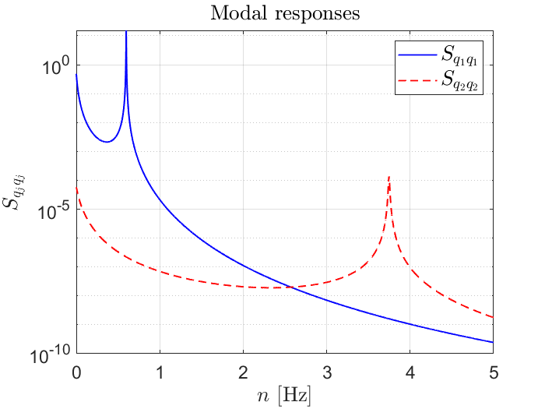
Fig. 1 Power spectral density of modal responses
5.2 Tables
Tables must be formatted as shown in Table 1 and referred in the text as “The correct page margins are listed in Table 1” or “...make sure to respect the correct page margins (Table 1)”.
Table captions are located above the tables, aligned to the left with 8.5pt font. The paragraph has 10pt minimum line space with 12pt blank space above and 6pt below. Use the predefined style tablelegend.
6 Equations
Equations must be centred and numbered sequentially. Numbers should be right justified. The paragraph has single line space with 6pt blank space above and below. No extra space is included between equations. Equations must be referred in the text as “Eq. (1) defines the kinetic energy”.
$K= \frac{mc^{2}}{\sqrt{1-{\left(v/c\right)}^{2}}}-mc^{2}$. | (1)
where m is the mass, v is the speed, and c is the speed of light in vacuum. All the symbols must be defined at their first appearance in the article. Scalar variables are indicated in italics, while matrices and vectors are bold-faces as:
$Ax=b$. | (2)
Equations must be referred in the text as “Eq. (1)” for one equation or “Eqs. (1), (2) and (3)” for multiple equations.
7 References
Use author-date style references (see References at the end of this document). Please note that the references at the end of this document are in the preferred referencing style, with examples given for books (Bendat and Piersol, 2000), journal articles (Andersen et al., 2005), conference papers (Baldwin and Lomax, 1978). References in text may also be cited as “Bendat and Piersol (2000) demonstrated that...”.
8 Conclusions
Once the text is complete, we recommend that you run a spell check through the text. Convert the document to a PDF file and upload it, together with the source Word file, through the on-line submission platform. Please go to www.icwe2023.com and follow the instructions under “Submission” in the section “About”. If you have any questions, please contact the Organising Committee at: org.committee@icwe2023.unifi.it.
For submission, the name of the file that you choose is not important. Files will automatically be renamed by our on-line system after submission. Please submit full paper by 15th January 2024. Please be aware that if the submitted full paper is not prepared according to above guidelines or it is submitted after the deadline, it will not be reviewed.
Acknowledgements The activity presented in the paper is part of the research grant …
References
Andersen, A., Persavento, U., and Wang, Z. J. (2005). Unsteady Aerodynamics of Fluttering and Tumbling Plates. Journal of Fluid Mechanics 541, 65–90.
Baldwin, B. S., and Lomax, H. (1978). Thin Layer Approximation and Algebraic Model for Separated Turbulent Flows. 16th AIAA Aerospace Sciences Meeting, Jan. 16-18, Huntsville, Ala.
Bendat, J.S., and Piersol, A.G. (2000). Random Data: Analysis and Measurement Procedures. Third edn. John Wiley & Sons, Ltd.
…

